**Online Diary**

**Task - Territorial acquisition**

**2.0 Introduction**

The task this week was to split into to teams and come up with a game about Territorial acquisition. The game should be playable with 2-4 players and should be designed using internet-based resources. The game must have one clear winner. We were also allowed to use other mechanics such as a top trump style game.

My team consisted of me, James and Jamie. At first, we named games that we could base our game on. I suggested fire emblem (<https://en.wikipedia.org/wiki/Fire_Emblem>) as the main concept of these games was to conquer a country by claiming territories. The main issue was that it was not a multiplayer game. After discussing about what game to do for a while a came up with the idea to do a card game that would utilize skill points depending on your role in the group. Coincidently my role was rules, James’s was the bored and events and Jamie’s was character design/development.

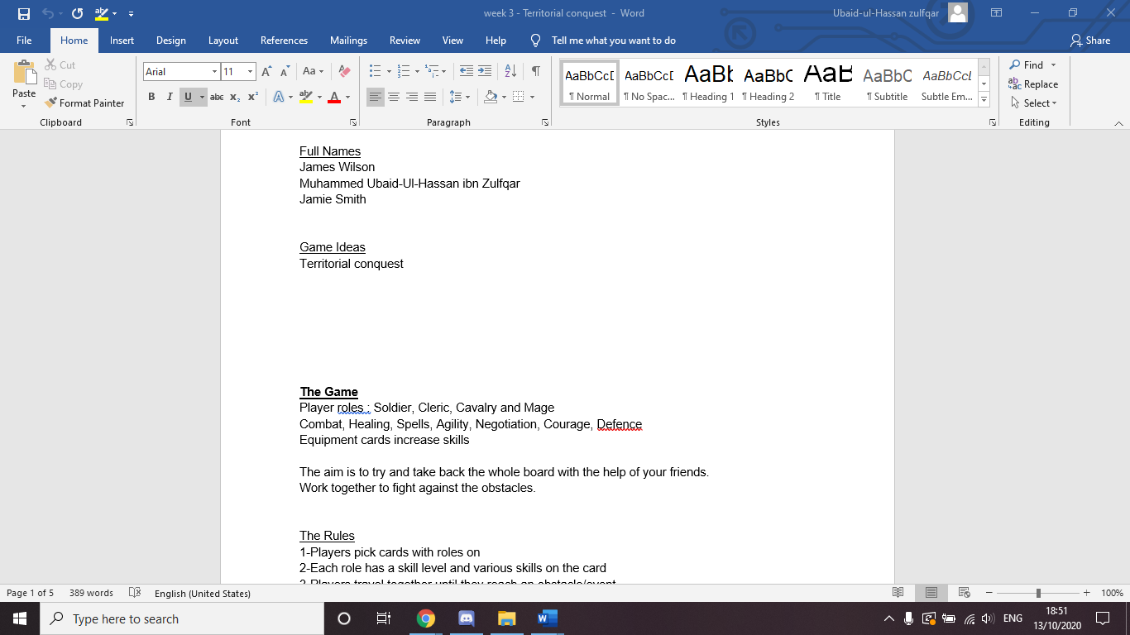

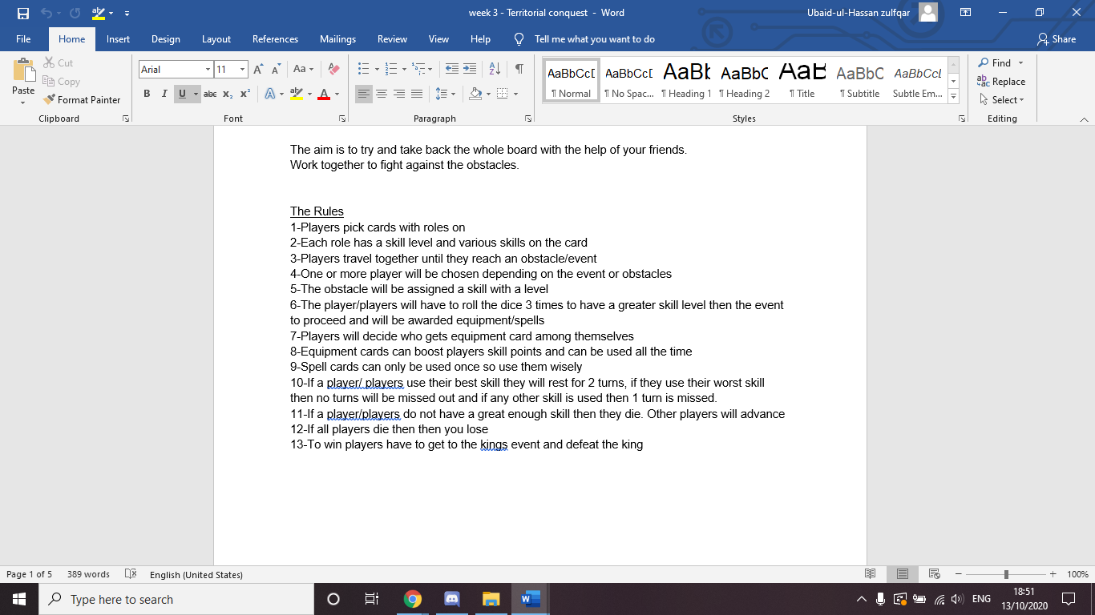

We started of making a plan of our PowerPoint using google docs. This made it so when we got to the actual PowerPoint, we would know what we should write instead of waffling or repeating certain points.

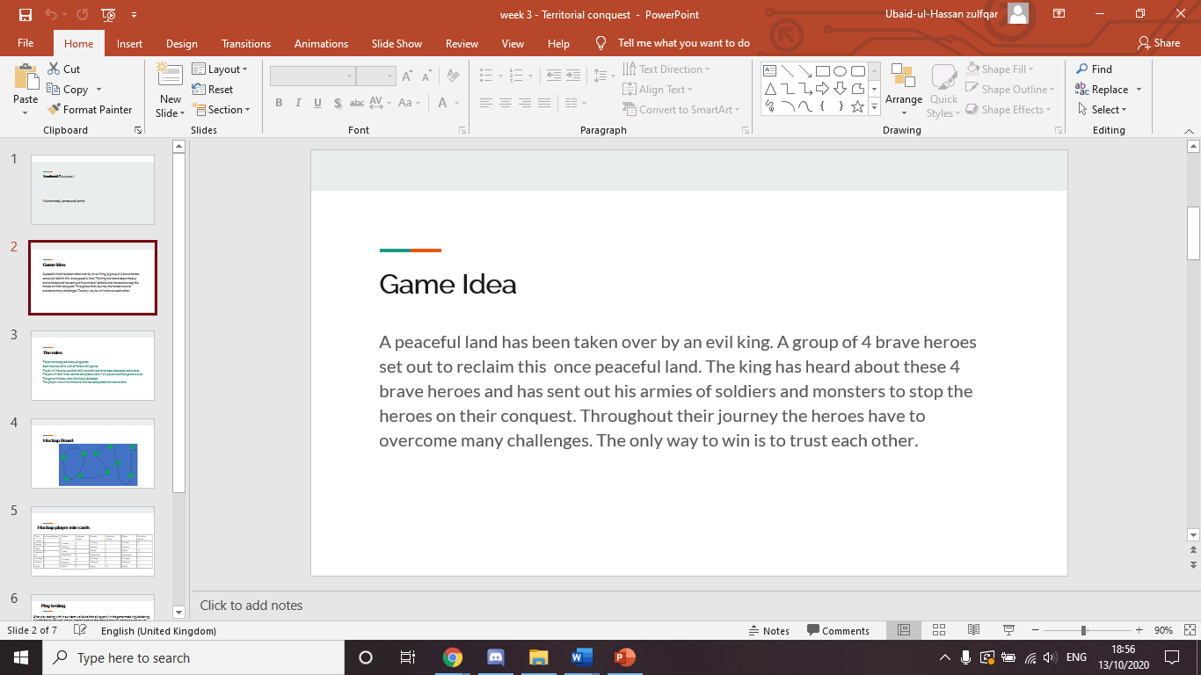

I decided to give the game a little back story. I asked for input from my other teammates as well. To be honest the story concept has probably been used in multiple other narratives but you know what they say if “isn’t broke don’t fix it.” We tried to link it to the idea of territorial acquisition to the game idea. The idea is for players to go around to defeating armies and claiming territories, resulting in the overthrowing of the king.

**2.1 Rules**

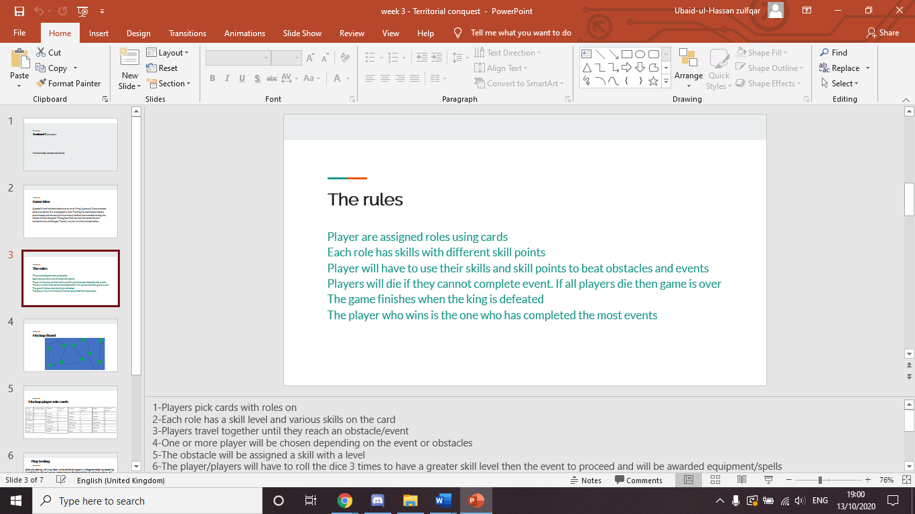

I copied and pasted the rules from our plan into the notes section which made easier to simplify the rules. To start the game players are given roles. These roles are given out random to avoid a bias/unfair game. The reason why I mentioned biased is each role have the same skills, however the skill points on the skill will be different. For example, the soldier has a skill point of 10 for courage but the cleric has skill point of 2 for courage.

The 4 players will make there away around the board together even until the very end. Throughout the game the players will come across events that can give players territories. The event will have a skill and skill level assigned to it, the players will choose 1 or more player to take on the event. The player/players chosen will role a d6 dice 3 times to boost their skill level. For example, a village is being overrun by thieves, you must choose one player, you must have a combat skill of 15 or greater to claim this territory.

To make sure that each person is give equal opportunities while playing the game we added a cool down system. If a player uses their worst skill, they are allowed to carry on normal. If a player uses their best skill then they will miss the next 2 events. Any skill in between players will miss 1 event only.

There are 2 ways for the game to end. One way is for everyone to die while trying to do event, all players lose then. The other is to defeat the king, after defeating the king the player with the most territories captured wins.

**2.2 Material**

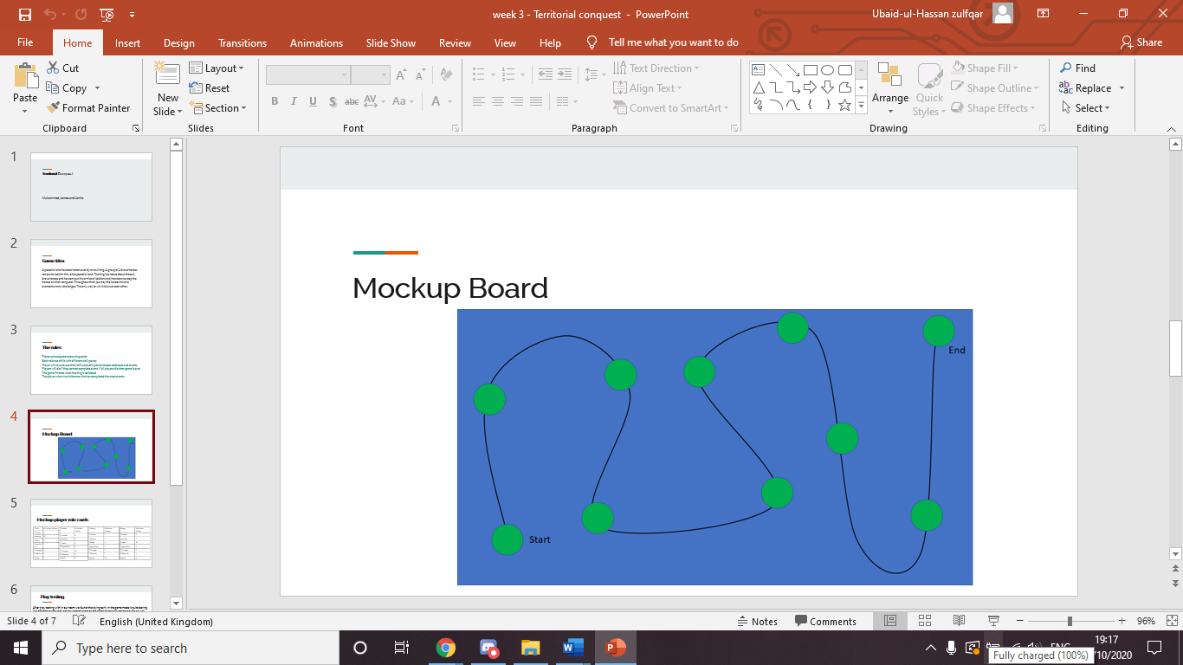

For our mockup board we added ten events. Players would travel linearly and not avoid any green dots on the board. The reason why a d6 dice was used was to boost the players stats not to move across the board. The events have not been added to the board as they were made on paper and should have been added why making the PowerPoint.

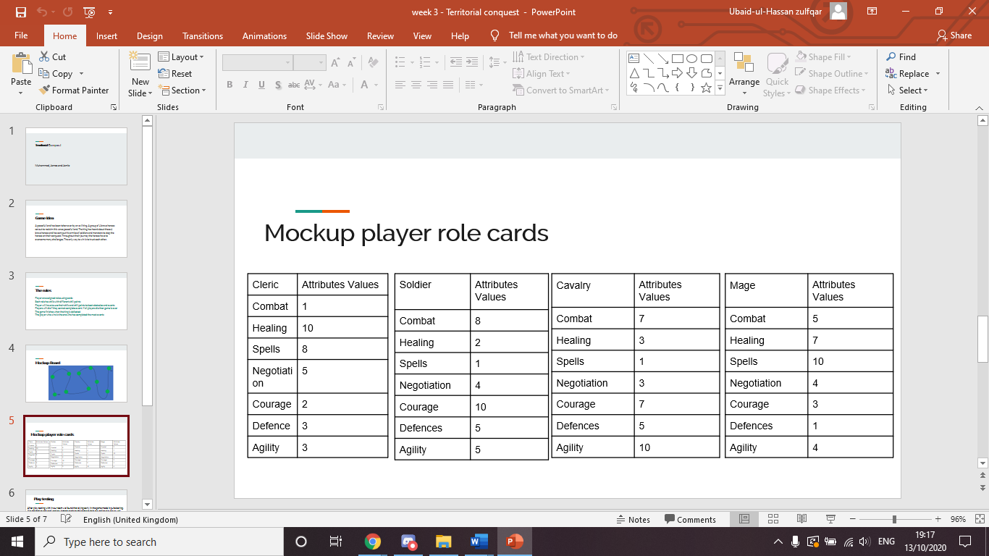

These were the first 4 role card we made. Instead of creating images we used tables, the reason why we used tables was because it was easier to manipulate the value of skills when rolling the d6 dice. We wanted to make more role cards so that players could come back and not just play as these 4 roles.

**2.3 Playtesting**

Unfortunately, we did not have enough time to playtest with other groups but we able to play test within our group.

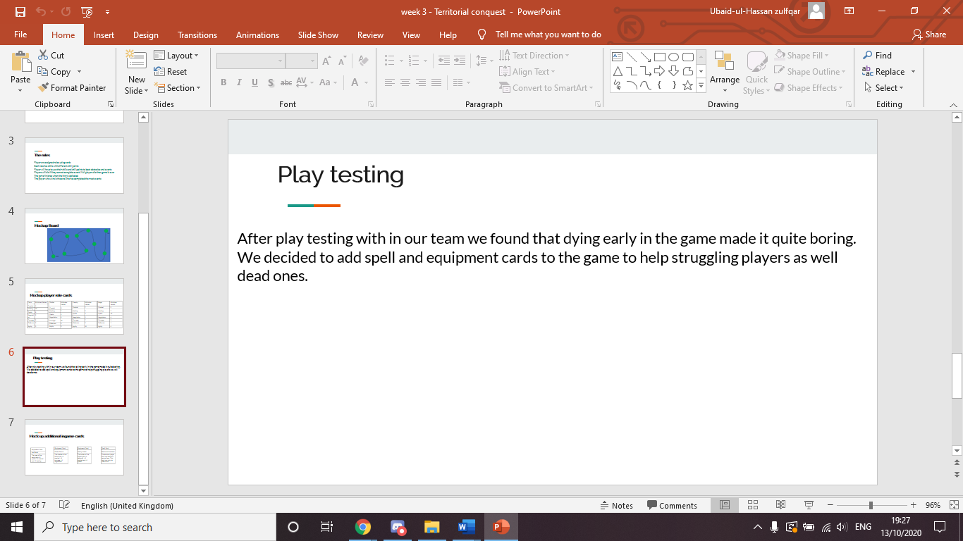

We released while playing that if you died at the beginning the rest of the game was not fun at all. So, we decided add in spell cards and equipment cards.

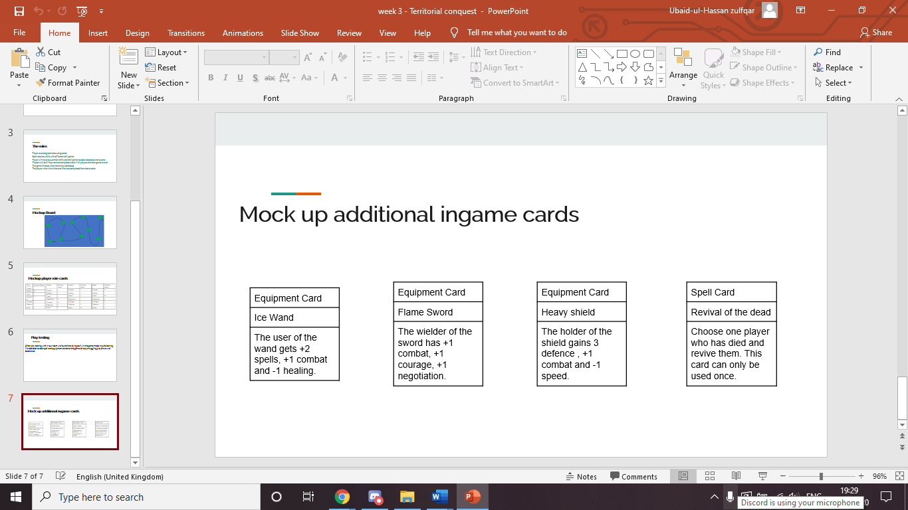

The difference between a spell and an equipment card is that spell card is destroyed after one use where as an equipment card is equipped to the player for the rest of the game. The spell card we made was a revival spell as that was why we made these cards in the first place. The equipment cards tell the player what stats it increases for example the flame sword increases negotiation, combat and courage all by one. These cards are given out after defeating an event and can be given to any player depending what the group decides. In a way it was even better that we made the cards table as once again it would be making modifying the skill level much easier. We wanted to make more of these cards but this one done after a play test so we limited for time.

**2.4 Reflection**

Overall, the game we ended up with differed from the other groups, mainly because we made a competitive teamwork game opposed a competitive multiplayer game. There was time where as a group we thought we weren’t going to get away with our game idea, the reason being was it doesn’t feel like a territorial acquisition game. Maybe we should have tried to stick closed to the brief then we did however we wanted to take a risk and hopefully it paid off.

